***Cloud Manufacturing Project***

**2. How long will your project take? Why is this the case? How have you calculated this? Provide the critical path (e.g. figure below) for your implementation. You may use the network diagram feature in MS Project (or equivalent) and modify/comment to illustrate your point, rather than redrawing from scratch (5 marks).**

By following the critical path on the network diagram (Of which is the path with the highest sum of days in a network diagram), it is estimated that the project will take around 1 year and 9 months. This is because I feel the team should take advantage of the most out of the given time scale of which is 2 years, this is to re ensure that there has been no rushed segments of this project of which ultimately minimised the risk of any issues coming up in the future, this can be seen in the critical path below, it is highlighted in red to show you which tasks are critical.

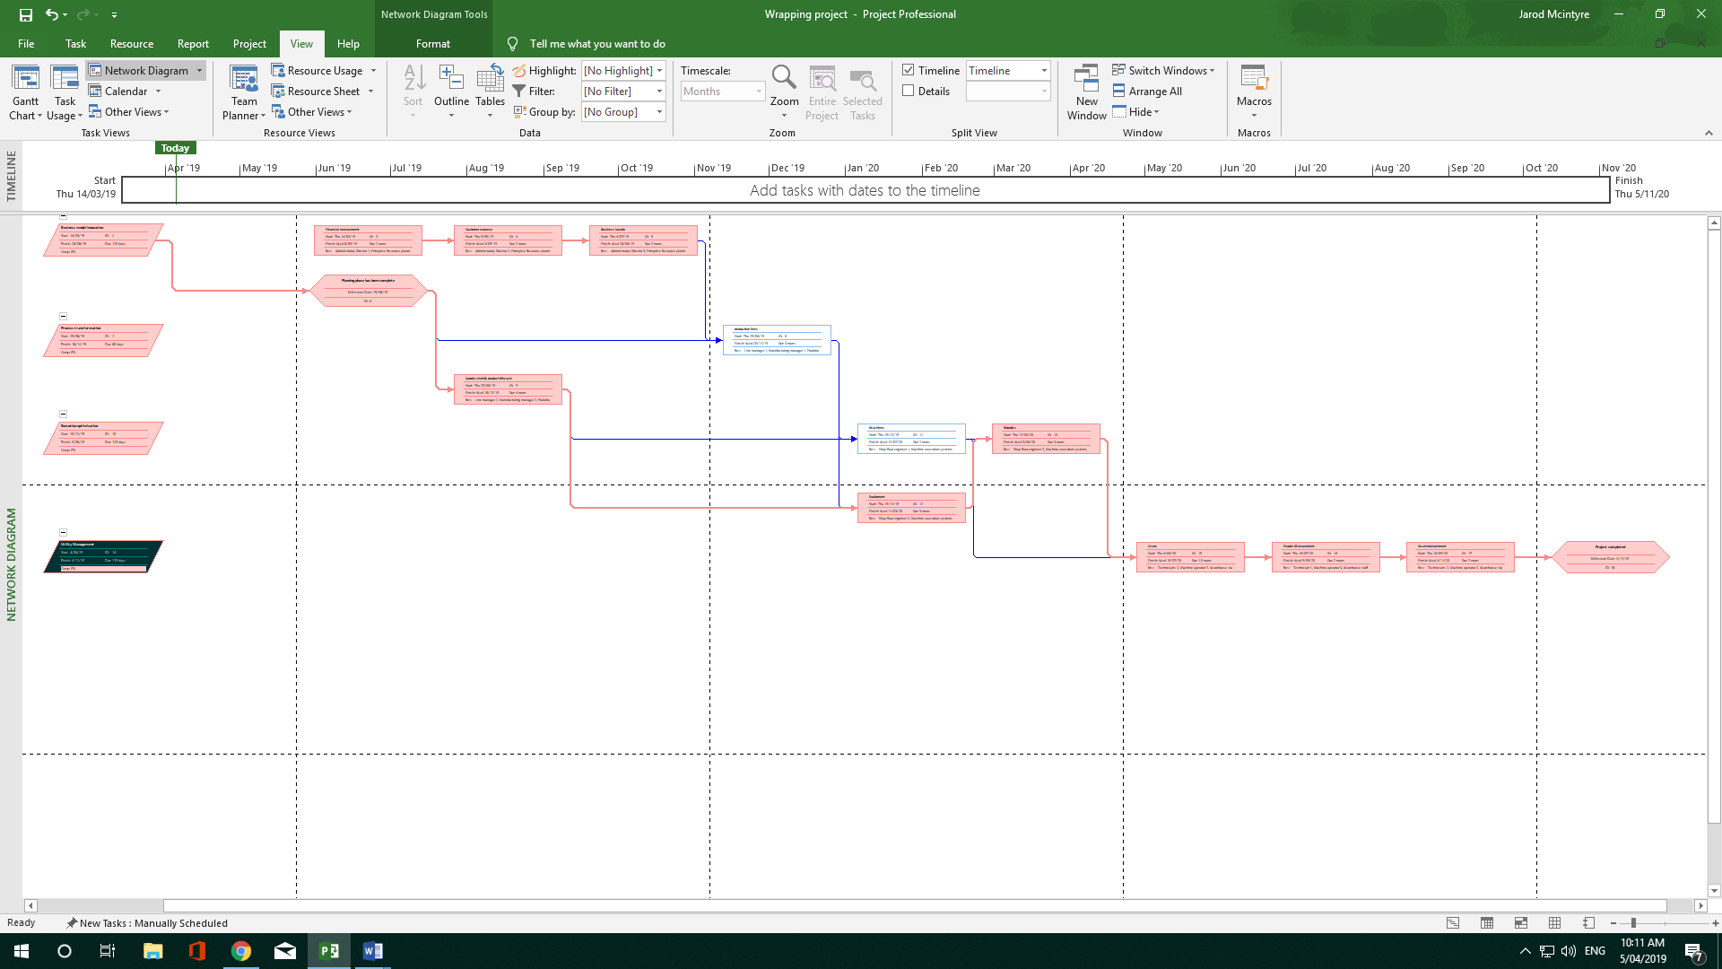**Figure 1. Network diagram**

**Figure 2. Gantt chart filtered to only show critical tasks**

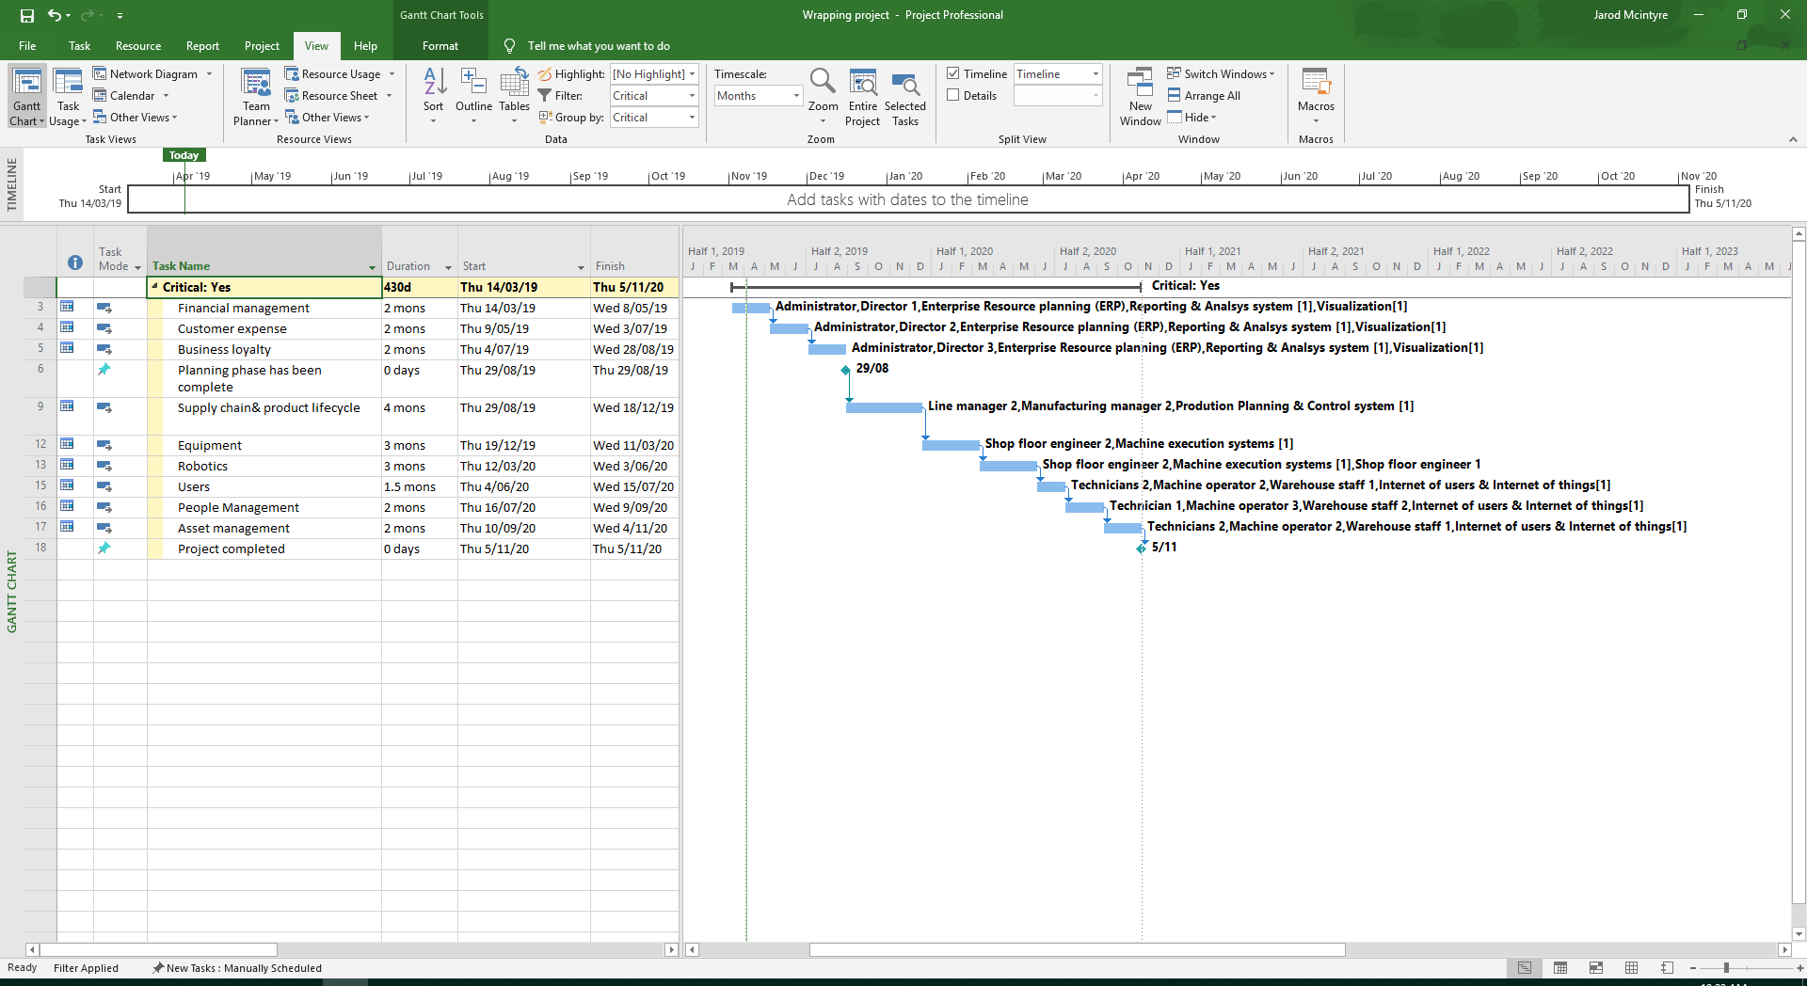

**3.Provide a discussion of your approach – how did you arrive at your costings, timeframes, how staff were allocated and so on? Hint: higher grades tend to refer to sources of information (5 marks).**

For the time framing, I approached this task with allowing plenty of time in the planning stages to ensure that all of the members of this project know exactly what to do and what is expected from them, (Alexander,Moria 2018) describes ‘ careful planning greatly reduces project failure rates’ so from this information I ensured we had adequate time to plan the project out, and due to this reason I made it so the three stages of planning had to be carried out separately and the admin would have to attend all of them at each of their stages, this ensured that due to the same admin managing the 3 processes there would be less redundancies.

The next area where I allowed for the most time is the optimisation period, this was to ensure that the project was running as fast and efficient as possible before releasing the CM project into the real working business, this had 120 ruled out for its completion and for the first two tasks the two floor engineers were working separately, however then in the last task they were working together. This was to ensure that no mistakes were made in the robotics phase.

In regard to how the tasks were linked together, I found it safer and more effective to ensure the previous major task had been completed before moving onto the next major task, this was to ensure that there was full attention on the task at hand to reduce and possibilities of redundancies.

The whole project has been estimated to be around 430 days total and in that time with all of the equipment, software and workers cost it was has been forecasted that we will have spent around $459,098,00 of which is around $290,902 under the $750,000 budget, I am confident with the added days spent in the planning phase we will be able to successfully implement CM into the workspace.

For the payrates for the employees I used a website called PayScale to gather information about each individuals salary and what they should be using, to calculate the tools like ERP system for example I looked at a plethora of different ERP software price points aimed towards a SME for example Oracle and SAP and the from that I estimated how much that system would be per monthly basis, for the other tools I carried out a similar method.

**Screenshots of the project**

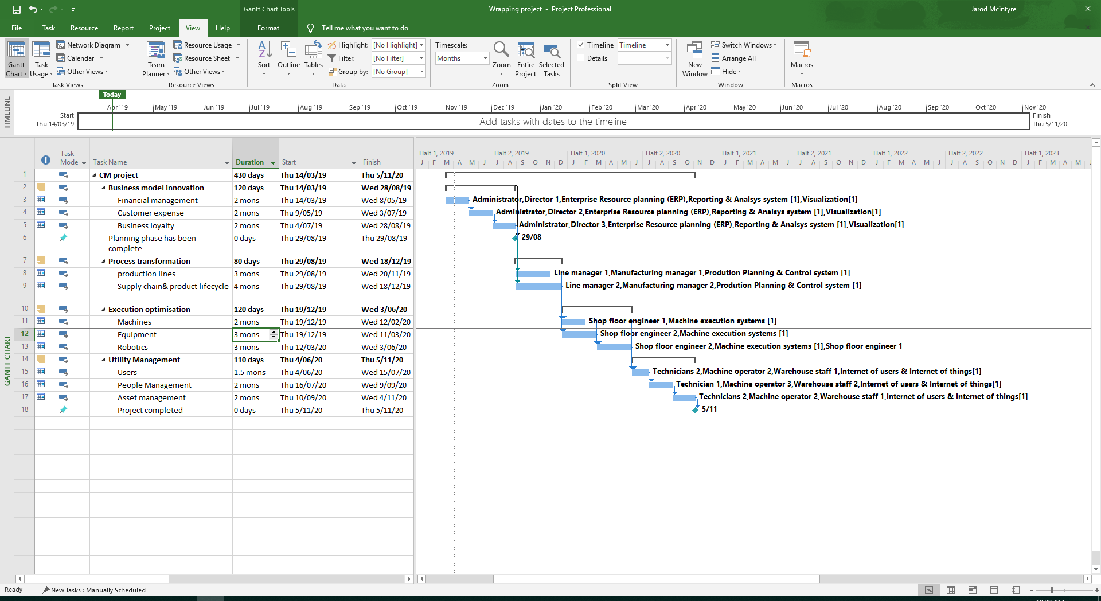**Gantt Chart**

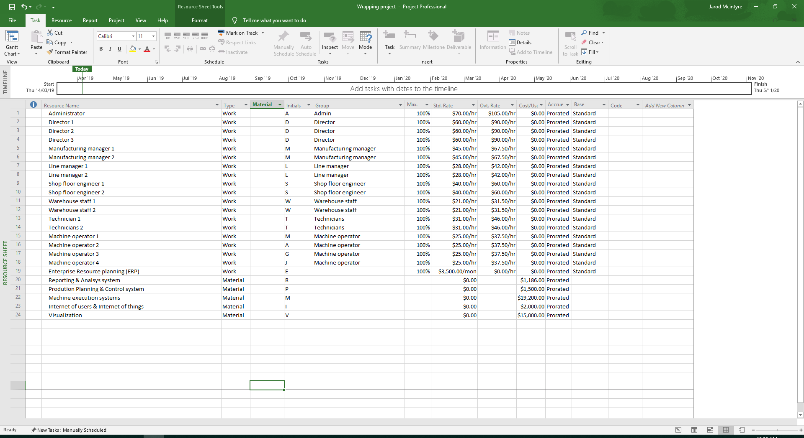**Resource sheet**

**Screenshots of the project continued**

**Network diagram**

**Bibliography**

ABJ Business Solutions. (2019). *The Importance of Business Optimisation - ABJ Business Solutions*. [online] Available at: https://www.abjsolutions.com.au/uncategorized/importance-of-business-optimisation/ [Accessed 5 Apr. 2019].

ABJ Business Solutions. (2019). *The Importance of Business Optimisation - ABJ Business Solutions*. [online] Available at: https://www.abjsolutions.com.au/uncategorized/importance-of-business-optimisation/ [Accessed 5 Apr. 2019].

Alexander, M. (2019). *Why planning is the most critical step in project management*. [online] TechRepublic. Available at: https://www.techrepublic.com/article/why-planning-is-the-most-critical-step-in-project-management/ [Accessed 1 Apr. 2019].

Go.oracle.com. (2019). *Watch a Demo of Oracle ERP Cloud*. [online] Available at: https://go.oracle.com/LP=68904?elqCampaignId=48487&src1=ad:pas:go:dg:erp&src2=wwmk160606p00034c0001&SC=sckw=WWMK160606P00034C0001&&&mkwid=sGdljUHUr%7cpcrid%7c325660115963%7cpkw%7coracle%20erp%7cpmt%7ce%7cpdv%7cc%7csckw=srch:oracle%20erp&&mkwid=sGdljUHUr%7cpcrid%7c325660115963%7cpkw%7coracle%20erp%7cpmt%7ce%7cpdv%7cc%7csckw=srch:oracle%20erp&gclid=Cj0KCQjw1pblBRDSARIsACfUG12Fp3M1ZUkSdXUToRc0_Xr3As-pfDWeDy_OxKsx7mzQtudcqVqUBRwaAkWkEALw_wcB&gclsrc=aw.ds [Accessed 2 Apr. 2019].

Payscale.com. (2019). *Australia Salary Survey - Average Salary in Australia | PayScale*. [online] Available at: https://www.payscale.com/research/AU/Country=Australia/Salary [Accessed 3 Apr. 2019].

SAP. (2019). *ERP Cloud | SAP S/4HANA Cloud | Pricing*. [online] Available at: https://www.sap.com/australia/products/s4hana-erp-cloud/pricing.html [Accessed 2 Apr. 2019].